COEN 161 Web Programming 1 Fall 2014

TA: Wenliang Tong Email: wtong@scu.edu
Office hrs: Tues: 8.15AM-9.15AM and Fri: 1.15-2.15pm

Lab2 (100 pts)

In this lab, you will use Cascading stylesheets to add presentational aspects to your HTML pages.
Create a folder (if you have not done so, last week) called COEN161Labs. Extract the zipped file, lab2, under this folder.
You should see a lab2 folder with an images folder and lab2.doc, and html files.

Exercise 1 (10 pts)
In this exercise, you will understand the some of the precedence rules in CSS. Open the file, exercise1.html in a text editor and view it in a browser. You will see a h1 heading with yellow background and blue text and a h2 heading with blue background and white text.
You must now reverse the colors as follows:
- Change the background color to the font color and font-color to the background color. So, after your changes, the h1 element which has currently yellow background should have a blue (the current text color) background with yellow text. Reverse the colors similarly for h2 element.
- You cannot edit the changes in the style block given.

Exercise 1B (10 pts)
In this exercise, you will use ems and pixels to control the font sizes in the div areas given. View the file, exercise1B.html in the browser (Chrome or Firefox). Does the font-size of text in the different divs look the same?
Open the file, exercise1B.html in a text editor. Examine the html part and draw a picture of the divs given (Show each div as a box and show the nested divs. Label each div).

Now, examine the style section in the file. Some of the styles for the divs are already given.

An em is equal to the computed value of the ‘font-size’ property of the element on which it is used.
For example, if you have the following style definition for a class element as shown below,

.element {
font-size: 20px;
}
Then it means that 1 em defined on that element or any of its children would be equal to 20px.

Add the appropriate styles as follows as given in the comments in the style section. Please note that the font-size, if not set in the child, is inherited from its parent.

After your changes, view the file, exercise1B.html again in the browser (Chrome or Firefox). Does the font-size of text in the different divs look the same? Or different?

Exercise 1C (5 pts)
In this exercise, you will use pixels and percentages to set the width and the height of the divs. View the file, exercise1C.html in the browser (Chrome or Firefox). Now open the file, exercise1C.html in a text editor and make the changes given in the comments in the style section. View the file in the browser after every change.
- After you make change 1, what is the major difference you see from the previous screen?
Now, replace the original style.

The page container(the blue div) currently is NOT centered in the page. Add the following style to the #container –
margin: auto;

View the file again in the browser. Is the container centered in the page?

Exercise 1D (10 pts)
In this exercise, you will practice using margins, padding and borders. View the file, exercise1D.html in the browser (Chrome or Firefox). Open the file, exercise1D.html in a text editor and do the following changes:

- Change the width of the divs to your chosen value and see the result.
- Change the width of the container div to 940px (from current value of 760). Did the contained divs keep the proportions?
- Set the margin-bottom of div two to 10px; Set the margin-top of div three to 15px; View the file in the browser. Did the gap between the two divs(bottom margin of two and top margin of three) indicate a total gap of 25px? Or 15px? Or 10px?
- Provide borders (choose a width, style and color of your choice) for divs one and two (bottom borders), for div three (all four borders) and for div four (top border).
- Provide a padding of your choice for all divs. Check if the text looks better separated from the borders.

References:
Boxmodel: http://www.w3schools.com/css/css_boxmodel.asp
Margins: http://www.w3schools.com/css/css_margin.asp
Padding: http://www.w3schools.com/css/css_padding.asp
Borders: http://www.w3schools.com/css/css_border.asp
Exercise 2 (10 pts)
In this exercise, you will use internal styles to create styles for the lists on the page, exercise2.html. Open exerice2.html in the text editor and follow the directions (given as comments) and complete the exercise. After you make the changes, validate your page using http://jigsaw.w3.org/css-validator/

View it in the browser.

For List styles, refer: http://www.w3schools.com/Css/css_list.asp

Exercise 3 (15 pts)
In this exercise, you will control the border style, color and width to create a webpage with an image as shown below.

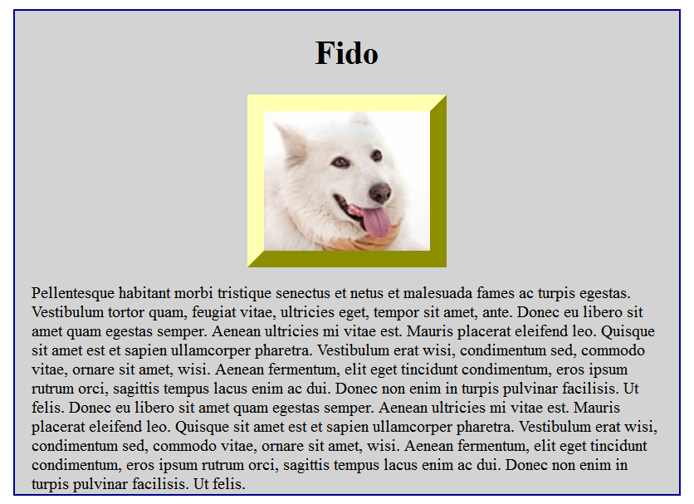

Open the file, exercise3.html and edit the HTML and styles to display the page as shown above.
Things to do:
- Add the image, fido.jpg (in the images folder) to the div. Use HTML 5 elements, figure (http://www.w3schools.com/html/html5_semantic_elements.asp)
to enclose the image.
- Center the image. To center the image, add the CSS styles, “margin-left:auto; margin-right:auto” into the img property, in the style section.
- Add a border around the image.
- Experiment with border-styles and select the border-style that displays as above.

Reference: http://reference.sitepoint.com/css/border-style

Exercise 4 (20 pts)
In this exercise, you will use the float property, to move elements on a web page.
Ref: http://www.w3schools.com/css/css_float.asp

Open the exercise4.html in a text editor and make changes (to HTML content as well as styles) such that the page displays as below (text wrapped around the images, one right aligned and one left aligned.

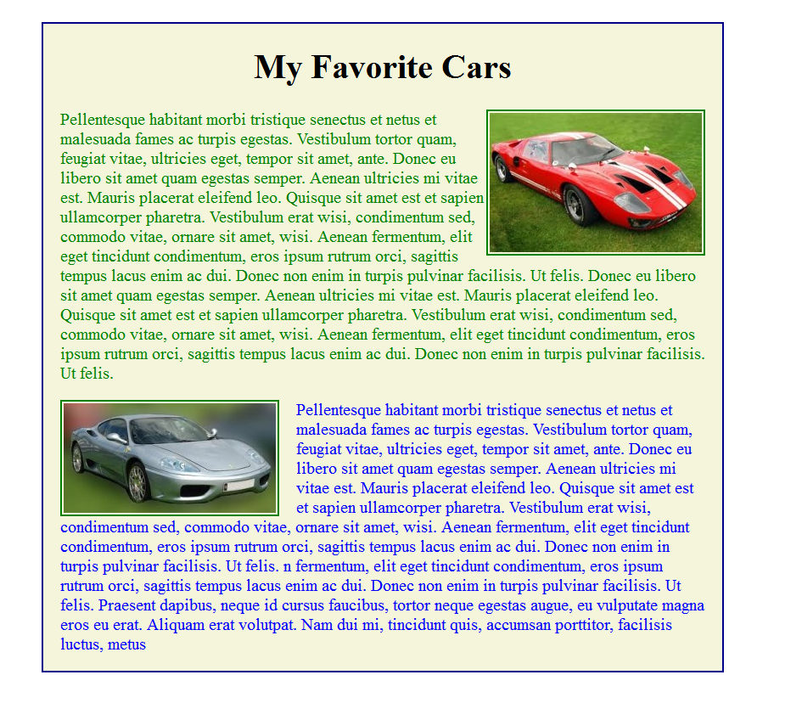
Points to note:

- Make sure you adjust the margins and paddings such that the page looks close to the picture shown.
- You are free to replace the text and headers (and images as well) with your choices.
- Use descendent selectors (eg: #two p, to refer to a paragraph that is a descendent of element with id two) and generic elements (p, h1, h2 etc) as much as possible, instead of creating ids for every element.

Note: To make it easier to read the style section, add a class called floatright and a class called .floatleft into the style section. The float property in the classes should be set to right or left accordingly. Make sure you add the classes to the elements (images in this case) that you want to float left or right.

After you make the changes, validate your page using http://jigsaw.w3.org/css-validator/

View it in the browser.

Exercise 5
In this exercise, you will explore using float and clear.

Exercise 5A (10 pts)

Open the file, threeBoxes.html in a text editor and the browser. You will see three colored, stacked boxes. Examine the HTML code in the file. You must now change the HTML code and styles, in threeBoxes.html to move the boxes to sit next to each as shown below.

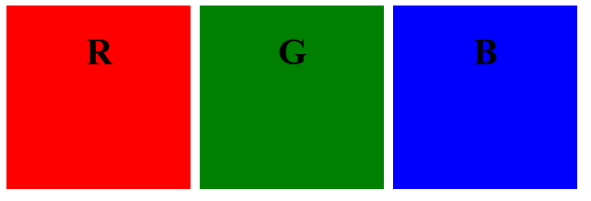

Steps:
- Save the threeBoxes.html as exercise5A.html.
- Edit the file to introduce the required changes to create the page as shown above.
- The letters in the boxes must be horizontally centered.

Hint: Think float.

Exercise 5B (10 pts)
Open the file, sixBoxes.html in a text editor and the browser. You will see six colored, stacked boxes. Examine the HTML code in the file. You must now change the HTML code and styles, in sixBoxes.html to move the boxes to sit next to each other in 2 rows, as shown below.

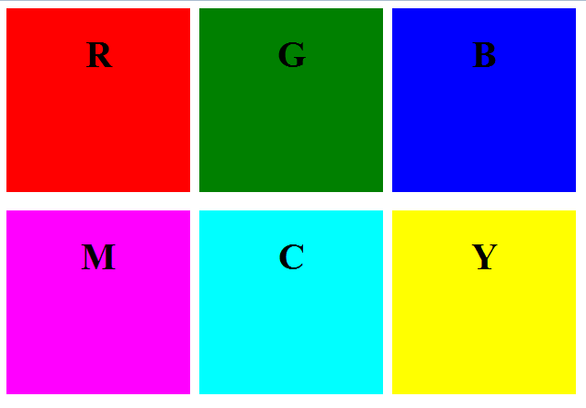

Steps:
- Save the sixBoxes.html as exercise5B.html.
- Edit the file to introduce the required changes to create the page as shown above.

Hint: Think float and clear.

After you make the changes, validate your pages using http://jigsaw.w3.org/css-validator/

View them in the browser.

